**Group Project**

**Topic: Mathematical Tool – Polynomial Generator of Degree N**

**West University of Timișoara**

**Math and Computer Science Faculty**

**Project Owner: Leonard Mada, Syonic**

**Team members:**

* **Dorin Doncenco**
* **Adrian Șereș**
* **Eduard Mirciov**

**Purpose**

This project has two goals: parsing a string into a data structure as a polynom, and generating a polynom of degree N.

**Implementation**

* **Polynom structure**

The language used is Java. Polynoms are stored using a TreeMap<Term, Double> where the Double represents a term coefficient and Term is in itself another TreeMap<String, Integer>. A term is made up of a variable name (such as a, b, x, y) and an Integer power.

* **Parsing the polynom using a finite state machine**

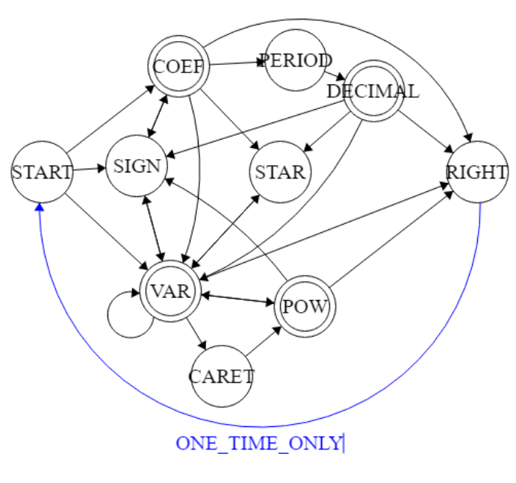

* **Polynom generation (pseudocode)**

function generatePolynom(int n, Polynom root){

int counter = 1, m = n

Polynom result;

Polynom b[m]

b[m] = 0

// rational terms are polynoms whose power of k is a multiple of n (0, n, 2*n, etc)

Polynom toBeRationalised = root

while(m > 0)

{

b[m-1] = n * (rationalTerms(toBeRationalised) / counter

Polynom poly = Polynom(“x^m-1”)

result.add(b[m-1] * poly)

toBeRationalised = (toBeRationalised - b[m-1]) * root

counter++

m--

}

b[n] = Polynom(“x^n”)

result.add(b[n])

return result

}

* **Graphical User Interface**

The GUI is written using the Jframe class. The available functions are add, Get Polynom, Sum, Multiply, Diff, DivideByNumber and GeneratePolynom.

”add” takes the input polynom and adds it to the polynom list.

”Get Polynom” allows the user to view the Polynom list.

”Sum” calculates the sum of two polynoms.

”Multiply” calculates the product of two polynoms.

”Diff” calculates the difference between two polynoms.

”DivideByNumber” allows the division of a polynom by a number.

”GeneratePolynom” generates a polynom using a root and a specified degree.